C.V
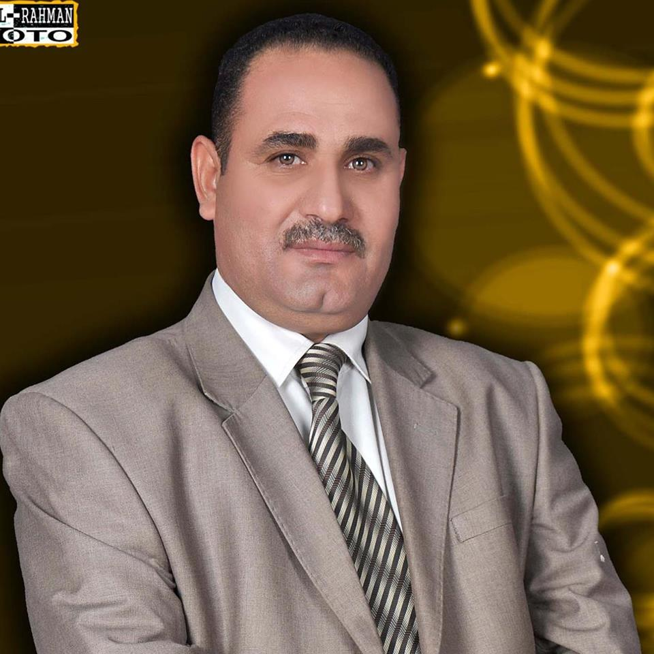

Photo

Name: MOHAMMED OLEIWI KANOA SAkBAN ALCHLAIHAWI
Date of Birth: 1/7/1971
Religion: Muslim
Martial statues: Married
Specialization: Accounting
Position: Teaching
Scientific Degree: Teacher
Work Address: University of AL- Qadisiyah / College of Administration and Economics
E-mail: mohammed.kanoa@qu.edu.iq

Scientific Certification:

Date | College | University | Degree science
2008 | College of Administration and Economics | University of AL- Qadisiyah | B.Sc.
2014 | College of Administration and Economics | University of Kufa | M.Sc.
2021 | College of Administration and Economics | University of Baghdad | Ph.D.
 |  |  | Any other
Date | Scientific Title | No.
15/1/2015 | Assistant Teacher
21/3/2021 | Teacher
Scientific Title

Courses Which You Teach:

Year | Subject | Department | No.
2014-2015  2015-2016 | Management Accounting | Accounting
2016-2017 | International Accounting | Accounting
2020-2021 | Intermediate accounting | Accounting
2021-2022 | Cost accounting | Accounting

Thesis which was supervised by :

Year | Department | Thesis Title | No.

Conferences which you participated:
Type of Participation | Place | Year | Conferences Title | No.  ( بحث / بوستر حضور)
Organizing Committee | College of Nursing | 2016 | Evaluation Conference in the College of Nursing | 1
Presence | Administration and Economics | 2014 | Seminar for the Accounting Departmentsymposium of the accounting department | 2
scientific committee | Administration and Economics | 2022 | conference | 3
sharing | Administration and Economics | 2021 | Workshops number (2) | 4
sharing | Administration and Economics | 2022 | Workshops number (1) | 5
Presence | Administration and Economics |  | Workshops number (30) | 6
 |  |  |  | 7

Scientific Activities:
Outside the College | Within the College
 | Evaluation scientific researches (7)
 | scientific initiatives (2)
 | Evaluation scientific of theses (1)
 | Member of the discussion committee(5)
1 | Master theses arbitration (1)

Awards and Certificates of Appreciation:

Year | Donor | Name of Awards and Certificates | No.
2008 | Ministry of Higher Education | certificate of appreciation | 1
1995 | Directorate of Civil Defense | Directorate of Civil Defense | 2
2010 | University's presiden | Directorate of Civil Defense | 3
2013 | University's presiden | thanks and appreciation | 4
2014 | University's presiden | thanks and appreciation | 5
2014 | University's presiden | thanks and appreciation | 6
2015 | College of Nursing | thanks and appreciation | 7
2015 | College of Nursing | thanks and appreciation | 8
2015 | College of Nursing | thanks and appreciation | 9
2016 | College of Nursing | thanks and appreciation | 10
2016 | College of Nursing | thanks and appreciation | 11
2017 | College of Nursing | thanks and appreciation | 12
2017 | College of Nursing | thanks and appreciation | 13
2020 | Ministry of Higher Education | thanks and appreciation (2) | 14
2021 | Ministry of Higher Education | thanks and appreciation (3) | 15
2022 | Ministry of Higher Education | thanks and appreciation | 16
2022 | prime minister's office | thanks and appreciation

Books Composed or Translated :
Year | Donor | Name of Awards and Certificates | No.
 |  |  | 1
 |  |  | 2
 |  |  | 3
 |  |  | 4
 |  |  | 5
 |  |  | 6

languages:
- Arabic
- English

Publication
Year | Publication | No.
2014 | Evaluating organizational performance by adopting Contingency theory of management accounting. | 1
2019 | The Impact of IFRS 15 Revenue from Contracts with Customers on Accounting Earning Quality . | 2
2020 | Use material flow cost accounting technology to achieve product sustainability. | 3
2020 | The Use of Product Life Cycle Assessment Technology to Achieve Product Sustainability | 4
2022 | Appropriateness of measurement and accounting disclosure of biological assets according to International Standard 41 in agricultural establishments | 5
2022 | The use of financial and non-financial performance measures in evaluating strategic performance | 6

